**SWEN303 Key Features**

**1.**

**FIXED Navigation bar**



A key feature that blackboard has but doesn’t use very well is a fixed navigation bar that can get you around the website from anywhere else.

* Navigation is always visible/Available to the user
* Enhances website navigation/flow
* Improves design by not distracting the user

2.

**Extended FIXED Navigation bar**

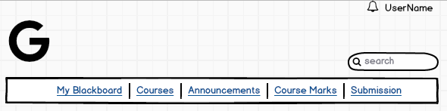

* Logo in top left/centre
  + Branding
* Bell icon
  + Standard bell icon used everywhere to notify users of anything important
* UserName displayed
  + This is important because the user wants to quickly see if they are logged in/out
* Search Menu
  + Current blackboard doesn’t have one. Users love searching, could search either blackboard or google.

3.

**Map**

Displays locations of your lecture halls & labs.

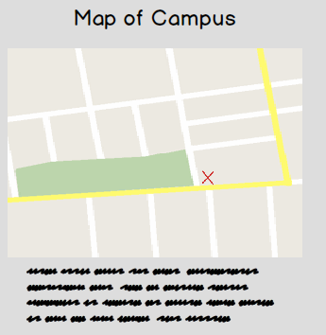

4.

**Easily readable, clean font.**

While this may not seem up there on importance I think it’s a key feature and we could discuss the use of font and how it engages users.

* Different fonts gives off different impressions (Arial,Helvetica,Verdana)
  + Elegance, professionalism etc..
* Arial is available everywhere, people are used to it.
* Helvetica looks bad on website, good for headers

Would be easy to discuss a page of why we chose this font. And headers. Typography is a big deal.

5.

**FIXED sidebar, upon course entering.**

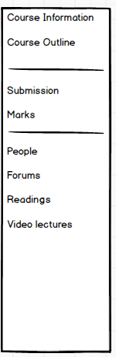

Sidebar once entering course navigation pages.

* Doesn’t disrupt flow
* Give the users a feel like they’re “inside” the course
* Gives links to specific details
* Include information that doesn’t fit on the page

I think the side navigation bar is a great. Current blackboard does a very bad job of using this feature. Some courses only have 3 links some 10+.

6.

**Lecturer/Course Coordinator only Announcement box**

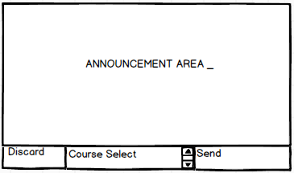

Simple announcement feature that lecturers and course coordinators would have access to.

Promotes constant communication with entire course.

Simple, easy to use.

7.

**Live chat**

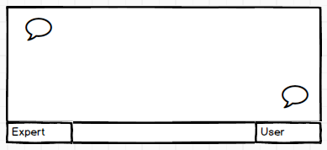

Live chat feature that is open between certain hours and lets you contact technical support or a course-coordinator if available during office hours.

**8.**

**Hamburger menu**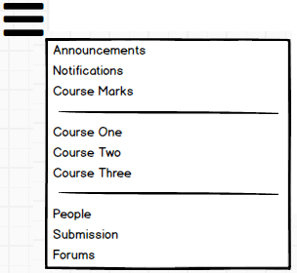

If we want to keep users attention to the details on the website rather than the navigation bar the hamburger menu could provide a good option for a minimalistic approach.

Top left, Toggle click pops out to the right.